DOG_______ CAT_______ Animal Name: ________________ DATE: ________________
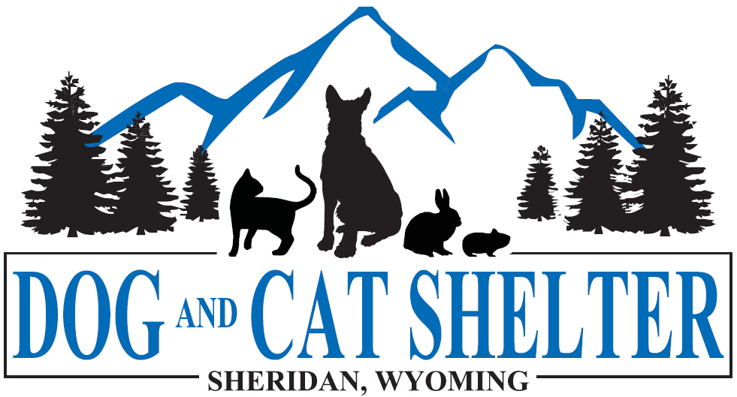
DOG AND CAT SHELTER
84 EAST RIDGE ROAD
SHERIDAN WY. 82801
PHONE: 307-674-7694
FAX: 307-672-6409
www.dogandcatshelter.org

ADOPTION APPLICATION
Thank you for your interest in adopting one of our animals. We are grateful for the opportunity to be able to work with you in choosing a new pet.
All Adoptable Animals Are:
*seen by our veterinarian *spayed or neutered
*up to date on their vaccinations *microchipped

In Order to Adopt You Must:
* be 18 years of age or older * be able to provide proof of home owner ship
*if renting, have consent of your landlord *provide vaccines on current animals

Some General Adoption Guidelines for You to Keep in Mind:
- We do NOT do adoptions as gifts.
- Dog adopters: If you own another dog you may be required to do a ‘meet and greet’ between your dog and the dog you are interested in adopting. You must provide proof of vaccines. Meet and Greets can be scheduled at any time and take place here at the shelter. Ask the staff member assisting you with your adoption for more information on the ‘meet and greet’ process.
- In the unfortunate event that your chosen animal does not work for your family, we encourage you to return the animal. We DO NOT issue refunds, however we will work with you to find an animal that is more suitable for your family or situation.

Finally, please know that we reserve the right to refuse any adoption. Please understand that we strive to make the best match for both the animal and the potential adopters.
Thank you and we look forward to working with you throughout the adoption process.

*Please fill our this section completely*

NAME(s): __________________________________________________________________________________________

Physical Address: ___________________________________________________________________________________
Phone: __________________________________ Phone: __________________________________
Mailing Address: ____________________________________________________________________________________
Email Address: ______________________________________________________________________________________
**Do you want to receive our Monthly e-newsletter?
It’s free, it’s fun and it’s informative. _____YES _____NO

- Residence: _____OWN or _____RENT
LANDLORD’S NAME ADDRESS AND PHONE NUMBER: _______________________________________________

- VET RECORDS: I acknowledge that upon turning in this application that I have 48 hours to provide the shelter with proof of our current animal’s vaccinations. I am aware that the shelter may also use the provided veterinarian as a reference in the application process.
Your vet may send through Email: dogncat2@fiberpipe.net or Fax: 672-6409
Vet Name/Phone: ____________________________________________________________________________
Animal Names & Breeds: ______________________________________________________________________
___________________________________________________________________________________________
For Meet and Greet:
We understand that by being at the Dog and Cat Shelter our animals are at risk of being exposed to various diseases which include, but are not limited to, Kennel Cough, Ringworm, Rabies, Parvo, Distemper, and Upper Respiratory issues, etc. We agree that we will not hold the Dog and Cat Shelter liable for any illness contracted by our animals, any injuries to our animals and/or loss of our animals. To the best of our knowledge our animal has not bitten anyone in the last 10 days.
I further agree:
All of the above information I have given is true and complete. I understand that it is my responsibility to see and evaluate the pet for myself before agreeing to adopt the animal. I understand that the Dog and Cat Shelter has limited information about the history of this animal. I understand the shelter has told me everything that they are aware of medically or behaviorally. This animal will reside in my home as a pet. I will provide it with adequate food, water, shelter, attention, training and veterinarian care. I am in full agreement with the terms of adoption. I understand that neither the Dog and Cat Shelter or its Board of Directors is in any way responsible for any damage, accident or injury resulting from the placement of this dog into my household.

APPLICANTS SIGANTURE:
DATE:
ADOPTION APPLICATION INFORMATION:

In Order to Adopt I Must:
* be 18 years of age or older * be able to provide proof of home owner ship
*if renting, have consent of your landlord *provide vaccines on current animals

VET RECORDS: I have 48 hours to provide the shelter with proof of our current animal’s vaccinations. Your vet may send through Email: dogncat2@fiberpipe.net or Fax: 672-6409

Some General Adoption Guidelines for Me to Keep in Mind:
- We do NOT do adoptions as gifts.
- Dog adopters: If you own another dog you may be required to do a ‘meet and greet’ between your dog and the dog you are interested in adopting. You will need to bring proof that your dog is up to date on his distemper and rabies shots. Meet and Greets can be scheduled at any time and take place here at the shelter. Ask the staff member assisting you with your adoption for more information on the ‘meet and greet’ process.
- In the unfortunate event that your chosen animal does not work for your family, we encourage you to return the animal. We DO NOT issue refunds, however we will work with you to find an animal that is more suitable for your family or situation.

All Adoptable Animals Are:
*seen by our veterinarian *spayed or neutered
*up to date on their vaccinations *microchipped

Prices:
CAT:
*Kitten - $65
*Adult - $50
*Senior/Barn - $25
DOG:
*Puppy - $100
*Adult Medium to Large - $85
Adult Small - $125
*Senior – 50% off

